**Hamming Code**:

#include<stdio.h>

int main()

{

int data[20];

int dataatrec[10],c,c1,c2,c3,i;

printf("Enter 4 bits of data one by one:\n");

scanf("%d",&data[0]);

scanf("%d",&data[1]);

scanf("%d",&data[2]);

scanf("%d",&data[4]);

data[6]=data[0]^data[2]^data[4];

data[5]=data[0]^data[1]^data[4];

data[3]=data[0]^data[1]^data[2];

printf("Encoded data is\n");

for(i=0;i<7;i++)

printf("%d",data[i]);

printf("\nEnter received data bits one by one:\n");

for(i=0;i<7;i++)

scanf("%d",&dataatrec[i]);

c1=dataatrec[6]^dataatrec[4]^dataatrec[2]^dataatrec[0];

c2=dataatrec[5]^dataatrec[4]^dataatrec[1]^dataatrec[0];

c3=dataatrec[3]^dataatrec[2]^dataatrec[1]^dataatrec[0];

c=c3*4+c2*2+c1;

if(c==0)

{

printf("No Error while transmission of data");

}

else

{

printf("Error on position %d\n",c);

printf("\nData sent:");

for(i=0;i<7;i++)

printf("%d",data[i]);

printf("\nData received :");

for(i=0;i<7;i++)

printf("%d",dataatrec[i]);

printf("\ncorrect message is\n");

if(dataatrec[7-c]==0)

dataatrec[7-c]=1;

else

dataatrec[7-c]=0;

for(i=0;i<7;i++)

{

printf("%d",dataatrec[i]);

}

}

printf("\n");

}

**OUTPUT :**

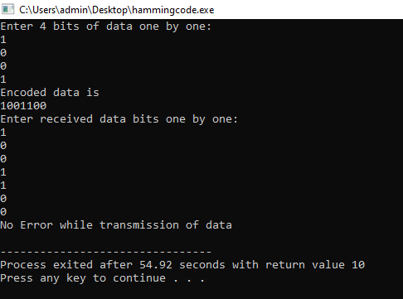

**Cyclic Redundant Code(CRC):**

**PROGRAM :**

#include<stdio.h>

#include<string.h>

#define N strlen(g)

char t[28],cs[28],g[28];

int a,e,c,b;

void xor1()

{

for(c=1;c<N;c++)

cs[c]=((cs[c]==g[c])?'0':'1');

}

void crc()

{

for(e=0;e<N;e++)

cs[e]=t[e];

do

{

if(cs[0]=='1')

xor1();

for(c=0;c<N-1;c++)

cs[c]=cs[c+1];

cs[c]=t[e++];

}while(e<=a+N-1);

}

int main()

{

int flag=0;

do

{

printf("\n1.crc12\n2.crc16\n3.crc ccit\n4.exit\n\n Enter Your Option:");

scanf("%d",&b);

switch(b)

{

case 1:strcpy(g,"1100000001111");

break;

case 2:strcpy(g,"11000000000000101");

break;

case 3:strcpy(g,"10001000000100001");

break;

case 4:return 0;

}

printf("\n Enter data :");

scanf("%s",t);

printf("\n-------------------------\n");

printf("\n generating polynomial is:%s",g);

a=strlen(t);

for(e=a;e<a+N-1;e++)

t[e]='0';

printf("\n-------------------------\n");

printf("\n Modified data is:%s",t);

printf("\n-------------------------\n");

crc();

printf("Checksum is:%s",cs);

for(e=a;e<a+N-1;e++)

t[e]=cs[e-a];

printf("\n-------------------------\n");

printf("\n final codeword is:%s",t);

printf("\n-------------------------\n");

printf("\n test error detection 0(yes) 1(no)?:");

scanf("%d",&e);

if(e==0)

{

do

{

printf("\n Enter the position where error is to be inserted:");

scanf("%d",&e);

}

while(e==0||e>a+N-1);

t[e-1]=(t[e-1]=='0')?'1':'0';

printf("\n-------------------------\n");

printf("\nErrorneous data:%s\n",t);

}

crc();

for(e=0;(e<N-1)&&(cs[e]!='1');e++);

if(e<N-1)

printf("Error detected\n\n");

else

printf("\n No error detected\n\n");

printf("\n-------------------------\n");

}while(flag!=1);

}

